Kansas Interscholastic Athletic Administrators Association

Spring Conference

ANNUAL SCRAMBLE GOLF TOURNAMENT
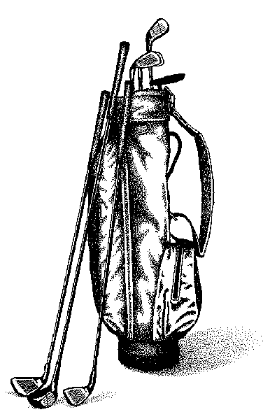
SUNDAY April 2, 2017
1:00 PM Shotgun Start

3 or 4-person Scramble Tournament
Cherry Oaks Golf Course
Cheney, KS
Check-in and payment: 12:00 – 1:00 pm in the Pro Shop

Participant fee is $50 and is to be paid ONLINE as part of your registration, OR paid ONLINE as a separate registration OR on site at the day of the event

Form needs to be emailed or faxed to Aaron Bucher
Includes cart, green fees and lunch
(Lunch sponsored by Daktronics)

Advanced Registration required by May 29

Contact:
Aaron Bucher at Arkansas City High School
aaron.bucher@usd470.com
School Phone (620) 441-2016
Fax (620) 441-2021

with your 18-hole average score
70-80___ 81-90___ 91-100___ 101-110___ 110-plus___

AD’s Name:_____________________________
AD’s School:____________________________

Soft spikes required!!
Good weather has been ordered!

***Teams will be put together based on a ABCD player rotation format.***

