Deerfield high school is looking for a pair of used football goal post. We are interested in the newer “Y” goal posts.

Please contact me if you have a pair that you are interested in selling.

Shane Burns
Deerfield 6-12 Principal/AD
Shane.burns@usd216.org
620 805-1775

Eudora High School has three Jammer machines for sale, they are gently used and work fine, just no room for them, they do not come with the plates. You would be responsible for picking them up at Eudora High School. $500.00 each, and if you want all three we could work out bundle price. Contact Cara Kimberlin, carakimberlin@eudoraschools.org or 785-542-4980

Douglas has a wrestling mat for sale $1000 obo. Contact Jason Menard at
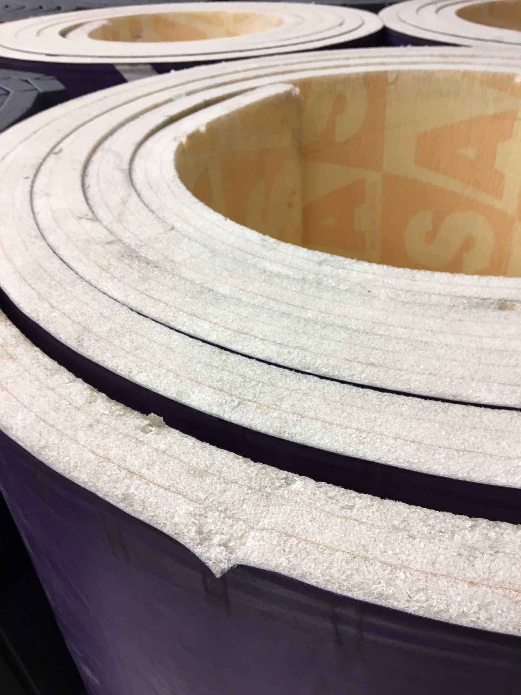
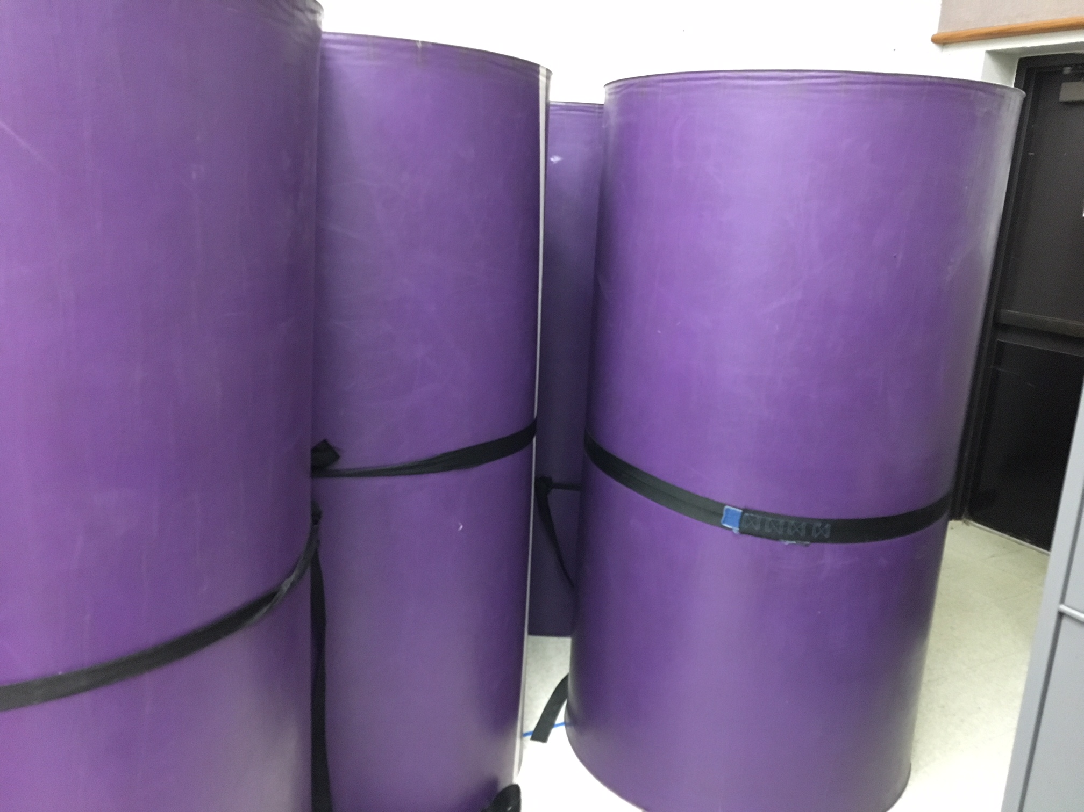
jmenard@usd396.net

